## Sennheiser Elevates Hybrid Learning Experience with TeamConnect Ceiling 2 at NTU Singapore’s Gaia

*12 units of TeamConnect Ceiling 2 installed in the auditorium NTU’s latest net-zero building*

***Singapore, 7 August 2024* – Sennheiser has installed its state-of-the-art TeamConnect Ceiling 2 (TCC 2) in the auditorium of Gaia, a net-zero building at Nanyang Technological University, Singapore (NTU Singapore), one of the world’s top universities, to elevate hybrid learning experience for its students.**

Gaia is home to NTU Singapore’s Nanyang Business School, one of the most established business schools in the Asia-Pacific region.​​​ At its 190-seat auditorium in Gaia, the school required a seamless communication system to support a hybrid learning experience for its diverse cohort.

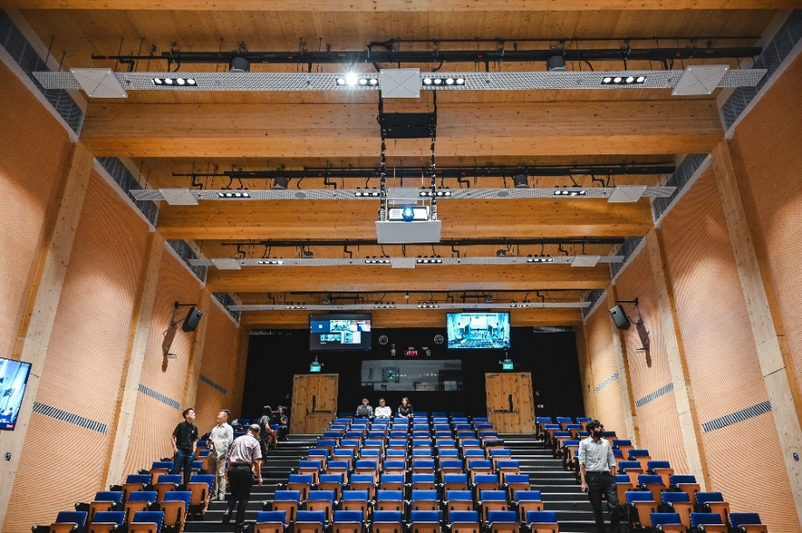

190-seat auditorium in NTU Singapore’s Gaia building

**A Tall Order**

The auditorium is characterised by a 9-meter ceiling height at the front with varying height running throughout the rest of the room due to the cascading theatre seating arrangement. To fit this auditorium with an AV system, the Sennheiser team had to calibrate the system and adjust for more than the recommended distance, while taking into consideration the differing ceiling-to-floor distance throughout the auditorium.

AV Media was the system integrator appointed for this project and they recommended Sennheiser’s TCC 2 as the solution. “Physical microphones are a thing of the past. They are inflexible and restrict the movement of the speaker. In addition, passing around a microphone also poses a huge hygiene risk. We knew immediately a ceiling microphone was the right solution for the auditorium, and we recommended Sennheiser’s TCC 2 for its superior audio quality and TruVoicelift functionality,” shared Eileen Goh, General Manager of AV Media.

**No More, No Less**

Given the size of the auditorium, multiple units of TCC 2 had to be installed. Over a period of two months, the Sennheiser team worked closely with the AV Media team to install 12 units of TCC 2 with intricate planning, simulations, and calibration in order to achieve the desired outcome.

The initial design planned for 18 TCC 2s to be installed in the auditorium, and following a detailed analysis, the amount was later reduced to 12. Two units of TCC 2 were installed at the front of the auditorium to serve as the pickup for the stage area, while the 10 other units were spread across the theatre seating area for audience pickup. The team was conscious about installing just the right number of TCC 2s to cover all areas of the auditorium so that no devices were deemed redundant.

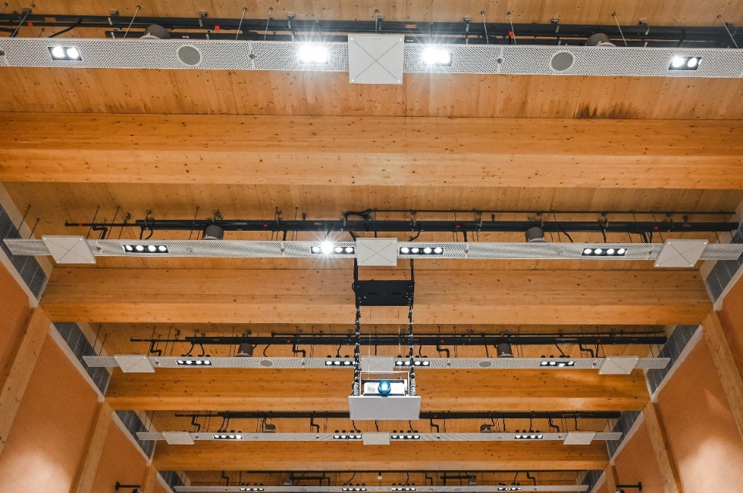

10 units of TCC 2 were installed in the ceiling across the theatre-style seating area for audience pickup.

“We also had to fulfil other requirements, like minimizing unwanted sound in the auditorium and ensuring that the lecturer’s volume is prioritized when multiple persons are speaking in the room,” Goh explained.

The TruVoicelift functionality includes a noise gate that can be activated during pauses in speaking to prevent background noises from being amplified. In addition, priority zone and advanced exclusion zones can also be set via the Sennheiser Control Cockpit, so that audio at the front of the lecture hall can be prioritized and unwanted background noises from air conditioning, other operating systems, doors and movement of chairs can be minimized. This is especially useful for a theatre with many operating systems and a potentially large audience.

The TCC 2 was also chosen as it could work seamlessly with the Q-SYS auto tracking camera to track the active speaker in the auditorium, so that remote participants would not miss out on key moments during lecturers and discussions and will feel more engaged and involved.

**Customization is Key**

With Sennheiser TCC 2, lecturers no longer must hold a microphone, allowing them the flexibility to move around without having to worry about compromising the audio quality. “Students can now enjoy excellent audio in class, where the speaker can be heard from every corner of the room. Most importantly, the system is easy to operate, and the lecturers can do so without technical assistance. This saves time and reduces cost in the long run,” added Goh.

Sennheiser TCC 2 was chosen for its superior audio quality and TruVoicelift functionality

The Sennheiser Control Cockpit also permits the setting of different user profiles to cater to the specific needs of diverse users, purposes and environments. “The lecturers have different preferences. Some may prefer the audio to be amplified, while others might lean toward a more natural level. All these can be easily customized from the backend,” added Spring Chong, Sennheiser Business Development Manager.

**About Sennheiser**

Audio specialist Sennheiser is one of the world's leading manufacturers of headphones, microphones and wireless transmission systems. Based in Wedemark near Hanover, Germany, Sennheiser operates its own production facilities in Germany, Ireland and the USA and is active in more than 50 countries. With 19 sales subsidiaries and long-established trading partners, the company supplies innovative products and cutting-edge audio solutions that are optimally tailored to its customers' needs. Sennheiser is a family owned company that was founded in 1945 and which today has 2,750 employees around the world that share a passion for audio technology. Since 2013, Sennheiser has been managed by Daniel Sennheiser and   
Dr. Andreas Sennheiser, the third generation of the family to run the company. In 2015, the Sennheiser Group had sales totaling €682 million.

www.sennheiser.com

**Local Contact Global Contact**

Phang Su Hui Jeffrey Horan

Suhui.phang@sennheiser.com jeffrey.horan@sennheiser.com

M +65 91595024 M +18603000081